Content:

1. Authors
2. Topic
3. Summary
4. Main stages in the implementation of the project
5. Logical and functional description of the program
6. Realization
7. Conclusion

1. Authors:

Name: Ilia Marinov

E-mail: IMMarinov18@codingburgas.bg

School: PGKPI, IXth A grade

Name: Aleksandar Yanev

E-mail: AZYanev18@codingburgas.bg

School: PGKPI, IXth B grade

Name: Martin Tsifondarov

E-mail: MDTsifondarov18@codingburgas.bg

School: PGKPI, IXth V grade

Name: Valentin Petrov

E-mail: VPPetrov18@codingburgas.bg

School: PGKPI, IXth G grade

2. Topic:

The topic of our project is to demonstrate our skills of handling with strings and functions.

3. Summary:

The project can be presented as easily accessible software for ordering and delivering food. It is composed of two parts a menu with a wide variety of options and а game.

4. Main stages in the implementation of the project:

The development of the project went through the following stages:

* Research for information: We looked at many sources of information that could be useful for our project.
* Distribution of roles: Here we decided who will do which part of the project.
* Realization.

5. Logical and functional description of the program:

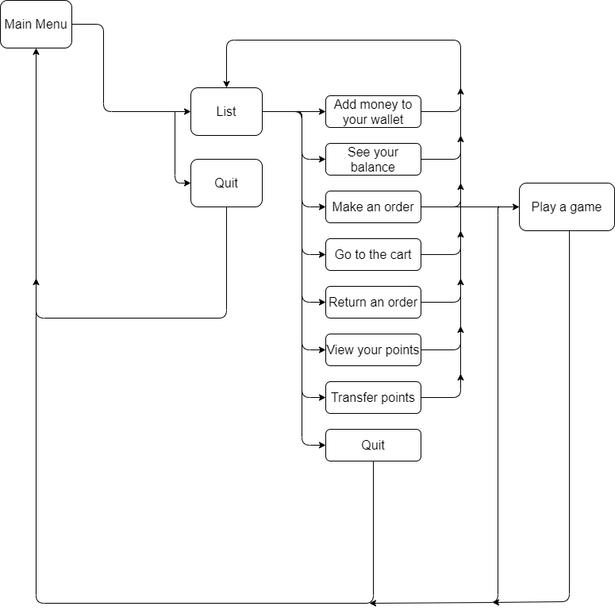

6. Realization:

For the realization of our project in the first place we formed a team and united under a common idea, as each of us contributed with a different approach and vision for its implementation.  
We researched and collected information from various sources to see how to properly use the string type.

We systematically and consistently started the work on the visualization of our idea, for which we used C ++ in the platforms Visual Studio 2019 and Visual Studio Code. After developing the software, we checked its functionality.

7. Conclusion:

We passed this time with the confidence that we have created a very user-friendly menu with a wide variety of options and foods.